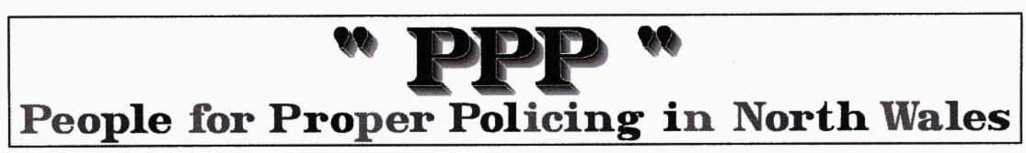
Campaign to turn A55 into North Wales motorway launched

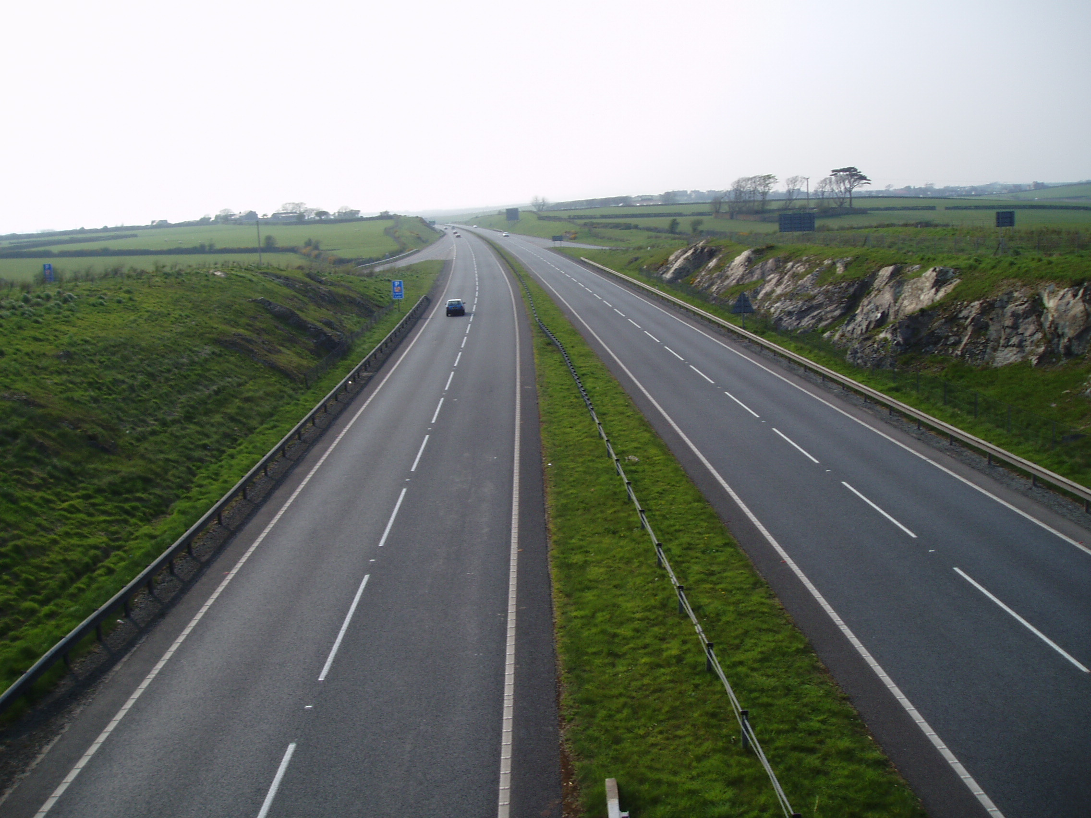
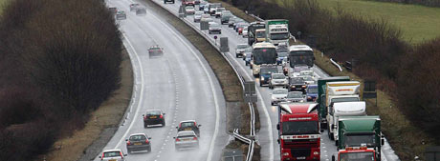
North Wales Daily Post Mar 16 2010

A CAMPAIGN to make the A55 a motorway has been launched in a bid to cut deaths and injuries on the road and reduce congestion. A petition has been lodged on the 10 Downing Street website and already has political support and the backing of a former deputy chief of police.

The change of status would require installing a hard shoulder along the route, upgrading lighting and signage, and the strengthening of road barriers and the central reservation. It would also prohibit vehicles like tractors and low powered motorbikes.

The Welsh Assembly Government would not be drawn on the road’s status but said it was determined to improve its safety record. (PPP comment .. let’s start by publishing this ‘record’)

Former deputy chief constable Bill Brereton said: "As a strategic route with a large volume of traffic, particularly freight traffic, the A55 should be a motorway as it serves as a vital route for transport across Europe. I know from policing the road of the problems in terms of congestion and safety and on those grounds I would support the road becoming a motorway. But the problem we have is paying for it."
Colin Hughes, of Denbigh, who started the petition, said: "Everyone knows how dangerous this road is and how easily it can become congested. Making this road a motorway would help alleviate some of the problems."

David Williams, chairman of the Llandudno Hospitality Association, said he would welcome any changes that would reduce congestion on the A55.

North Wales Police have highlighted safety issues along the route, which included having no hard shoulder, five bus stops, 88 lay-bys too short for lorries, a cycling track and roundabouts.

The Llandudno family of a girl killed after a lorry ploughed into their broken down car on the A55 have also previously called for a hard shoulder to be built. Joey Clark, whose 10-year-old daughter Chloe died at Rhuallt Hill in February 2008, said politicians were putting money over lives by not carrying out the safety improvements.

North Wales AM Eleanor Burnham said: "The A55 is like your washing machine, when it is working it is great but when it isn’t it can ruin your day. Making the A55 a motorway could certainly help with issues like safety and reducing congestion."

The cost of the upgrade and additional maintenance for the road would fall at the feet of the Assembly Government. A WAG spokesman said: "The A55 is recognised as a major European Union link, and is of huge importance to the economic prosperity of North Wales. Although statistics indicate that safety on the A55 is comparable with other roads of this class we are determined to improve the safety record and reduce accidents and disruptions to a minimum."

The petition is on http://petitions.number10.gov.uk/ImproveA55road

The PPP comments … We have been reporting incidents on the A55 for years and all our members are frequent users of this road. We believe that it is generally a safe and efficient trunk road and that the problems we see are due to two major factors, inherrent design errors and bad management and supervision. Design errors should have been obvious at the design stage and most could have been eliminated at reasonable cost. We believe that senior politicians with both transport and economy in their brief are responsible for not ensuring these issues were dealt with. Senior North Wales Police Officers who have been wise after the event should have insisted on being in on the design process. The major increase in HGV and other Ferry traffic was expected BUT no provisions were made for HGV rest and service areas. This raised the incident risk and lost potential revenue from areas adversely affected by being bypassed. Some of the most serious design errors are still there like ticking time bombs. These include the narrow lanes at Penmaenbach, the junctions without acceleration lanes at Pemmaenmawr west, Northop and Northop Hall and the ‘horrible’ Mold/Chester/QF interchange. One partial redesign used the flyover to Pen. beach to provide access INTO the town but DID NOT provide a west EXIT which it could easily have done (see photos below). How this daft design & waste of a flyover was passed originally is surprising. Many of the laybys are totally inadequate and really unsafe. They have no set back so an HGV driver stepping down from his cab is practically in the slow lane. i.e. criminally bad design . Long distance drivers are now sleeping in these laybys where they will be shaken by every passing vehicle. As we are told ‘tiredness kills’. It is not rocket science but these are the results of lousy management.
If a full HAZOP (hazard and operability study) was carried out at the design stage these costly (in terms of money and injuries) mistakes would be eliminated. Professionals from the Local Police force must be involved at this stage.
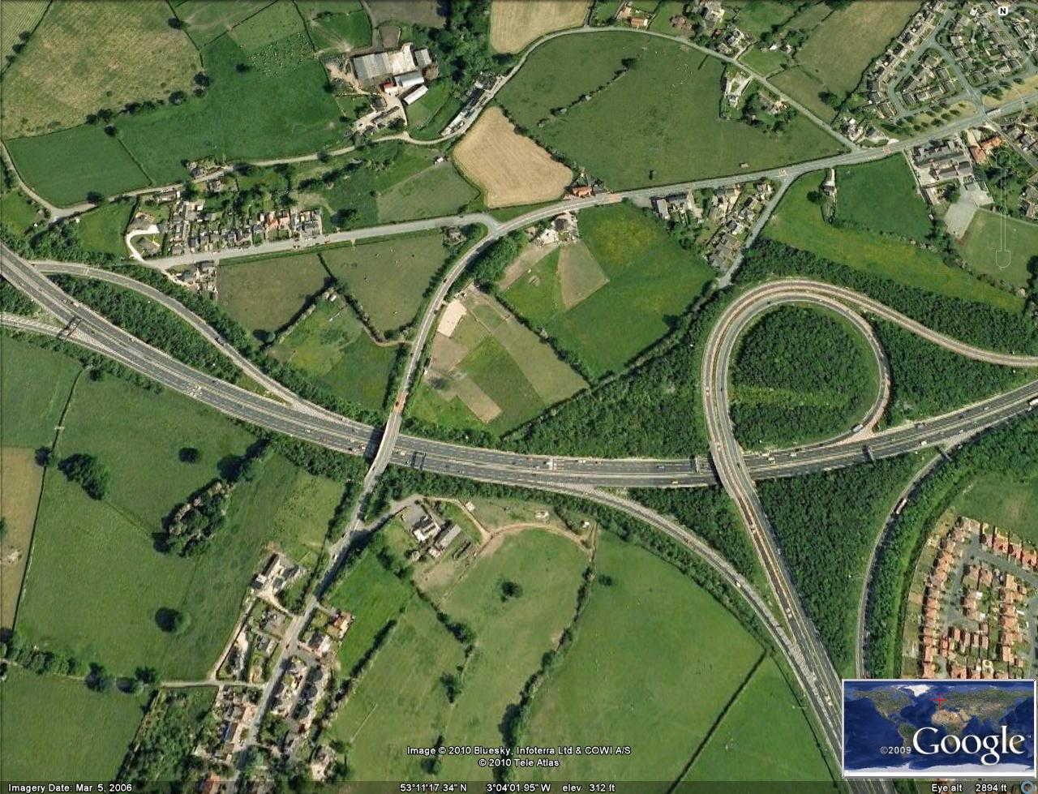
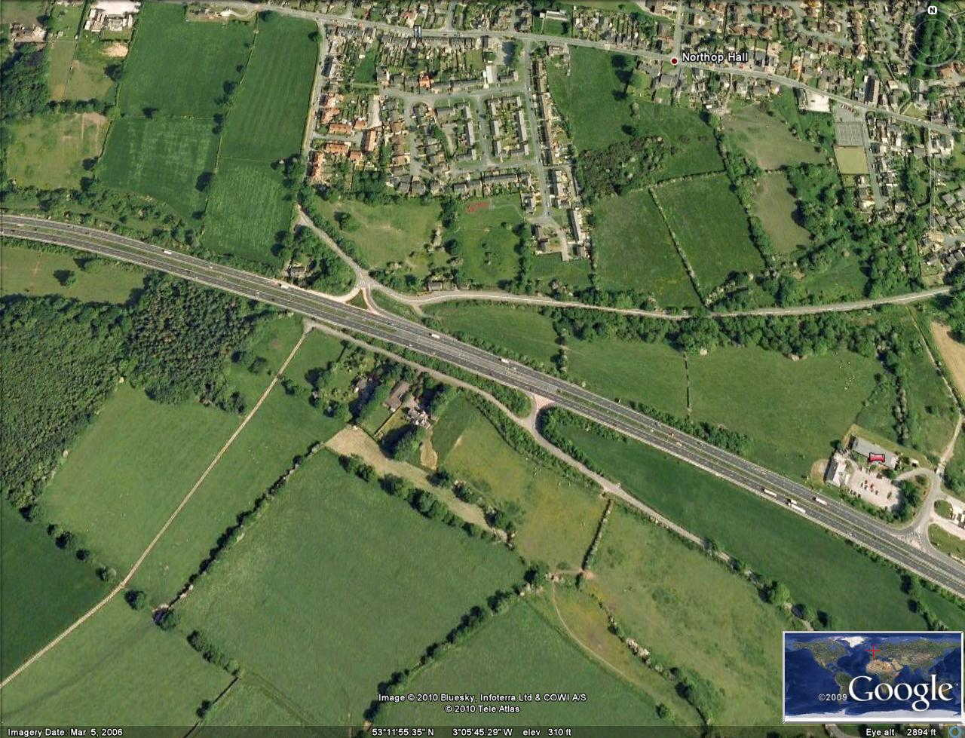
As regards the management and maintenance of the road there are inadequate highway patrol frequencies and less than full and intelligent use of the surveillance cameras. Road works seem to be excessively restrictive in extent and duration and there seems little incentive to get the job done quickly. As time is money, both as the cost of the work and the cost to those disrupted by the work this is unacceptable. A full survey of the time taken and reasons for all the maintenance work and costs should be carried out and published. The two photos on page 1 show the under utilised A55 in Anglesey (which we are still paying for as a PFI) and the congested version when being mismanaged by the WHA. If a full report on the Stats19 analysis of all the traffic incidents was compiled and published we could identify the primary problems/causes and target improvements accordingly. In a time of financial restraint knee jerk reactions and petitions don’t really get us anywhere. As the A55 is a premier tourist route there are very few facilities for the visitor and the USA style fully serviced scenic overlooks etc should be the model. They will provide refuges for tired drivers, breakdowns, patrol cars, phone users, families with children and lovers of our beautiful scenic countryside and generate jobs for locals. All the above proposals are based on the PPP core belief in sense & reason & prevention rather than punishment. NWPFs Chief Supt Anwyl’s contribution was to recommend installation of average speed cameras the length of the A55.
